CHAROTAR UNIVERSITY OF SCIENCE & TECHNOLOGY DEVANG PATEL INSTITUTE OF ADVANCE TECHNOLOGY & RESEARCH
Department of Information Technology

Subject Name: Data Engineering
Semester: 5th
Subject Code: ITUC301
Academic year: 2026-27 [ODD]
Practical File

PRACTICAL – 4

Problem Definition:
Implement and compare ETL and ELT pipelines using the same retail sales data. Measure their performance and understand their differences in data processing, lineage, recovery, and maintenance. Also implement the ELT transformation using dbt Core with automated tests.

Tools / Technologies:
- Python
- Pandas
- DuckDB
- SQL
- dbt Core
- CSV

Step 1 – ETL Pipeline
In ETL, data is first extracted from the CSV file. It is cleaned and transformed using Python/Pandas and then stored in DuckDB.
CSV → Extract → Pandas Transform → DuckDB

Step 2 – ELT Pipeline
In ELT, raw data is first loaded into DuckDB. The cleaning and transformation are then performed using SQL.
CSV → Extract → Raw Data in DuckDB → SQL Transform

Step 3 – Performance Comparison
Both pipelines were tested with 100,000 records.
Metric | ETL | ELT
Input Records | 100,000 | 100,000
Output Records | 100,000 | 100,000
Total Time | 0.8366 s | 1.9081 s
Latency | 836.60 ms | 1908.10 ms
Throughput | 119531.44 records/sec | 52408.15 records/sec
The result is based on the local test environment and the given dataset.

Step 4 – Latency
Latency means the total time taken by the complete pipeline.
Latency = Total Time × 1000
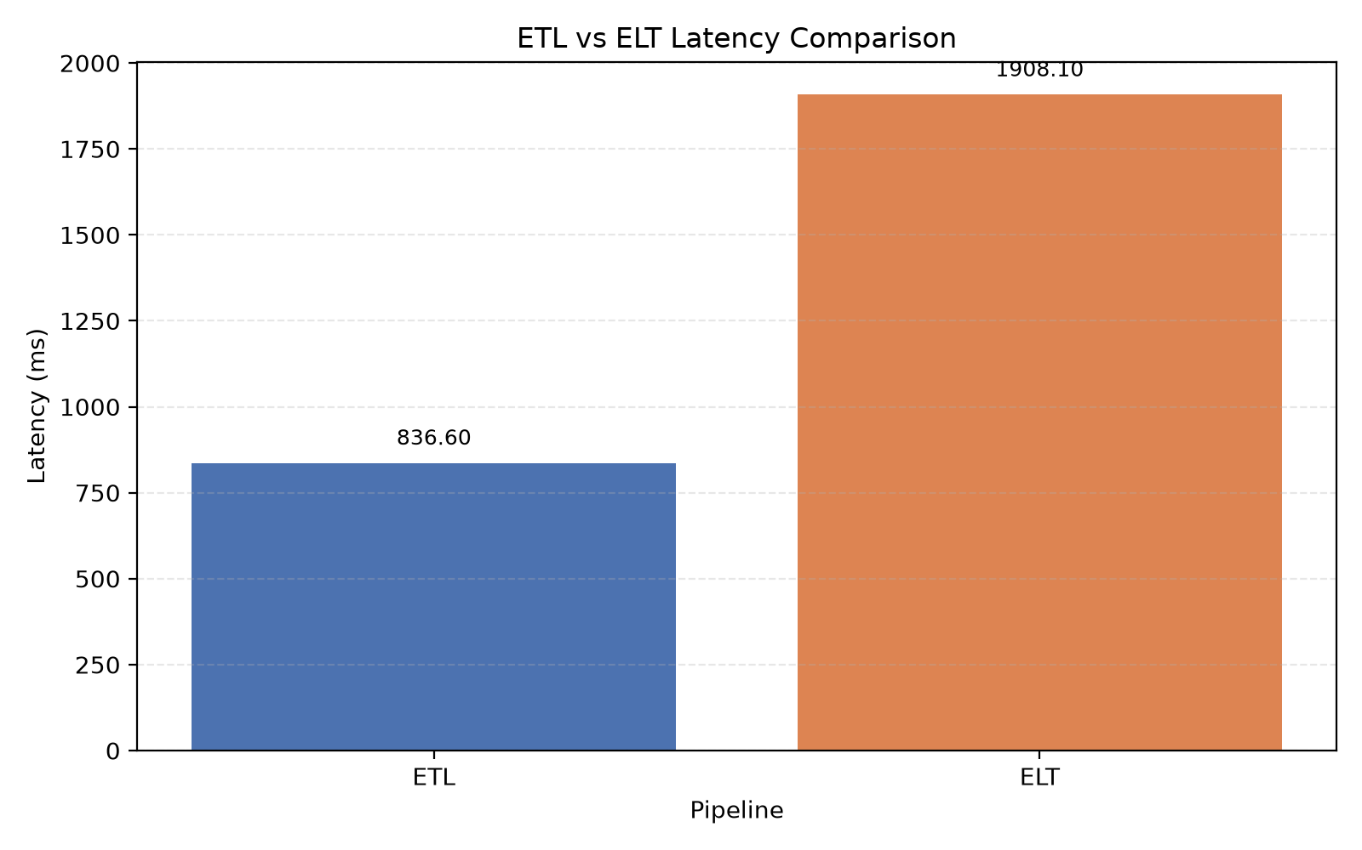

Step 5 – Throughput
Throughput shows how many records are processed per second.
Throughput = Output Records / Total Time

Key Questions

1. How does cloud compute and storage separation support ELT?
Raw data can be stored first and transformed later using scalable database or warehouse computing resources. This makes ELT useful for large cloud-based systems.

2. Which pipeline provides better data recovery?
ELT keeps the raw data in the staging area, so transformations can be corrected and run again without losing the original data.

3. How does network usage differ?
ETL may move data between the application and database during processing. ELT performs transformations inside the database, which can reduce unnecessary data movement.

Supplementary – dbt Core

Aim:
Refactor the ELT SQL transformation into modular dbt models and add automated schema tests.

dbt Models:
Raw Data
↓
stg_retail_sales
↓
retail_sales_clean
The project uses DuckDB as the database engine.
Schema tests were added using:
- not_null
- unique
- accepted_values
- relationships

Commands Used:
dbt debug --project-dir dbt_project --profiles-dir dbt_project
dbt run --project-dir dbt_project --profiles-dir dbt_project
dbt test --project-dir dbt_project --profiles-dir dbt_project
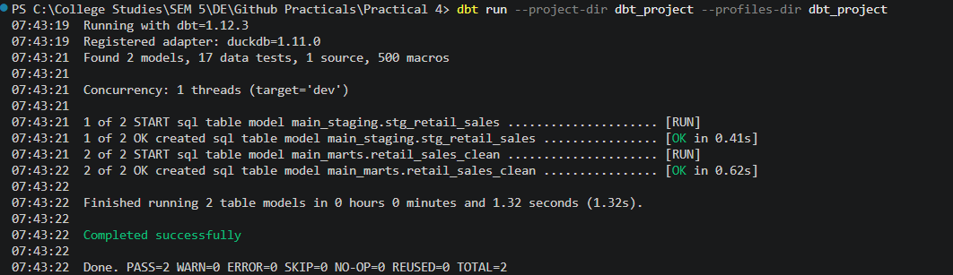
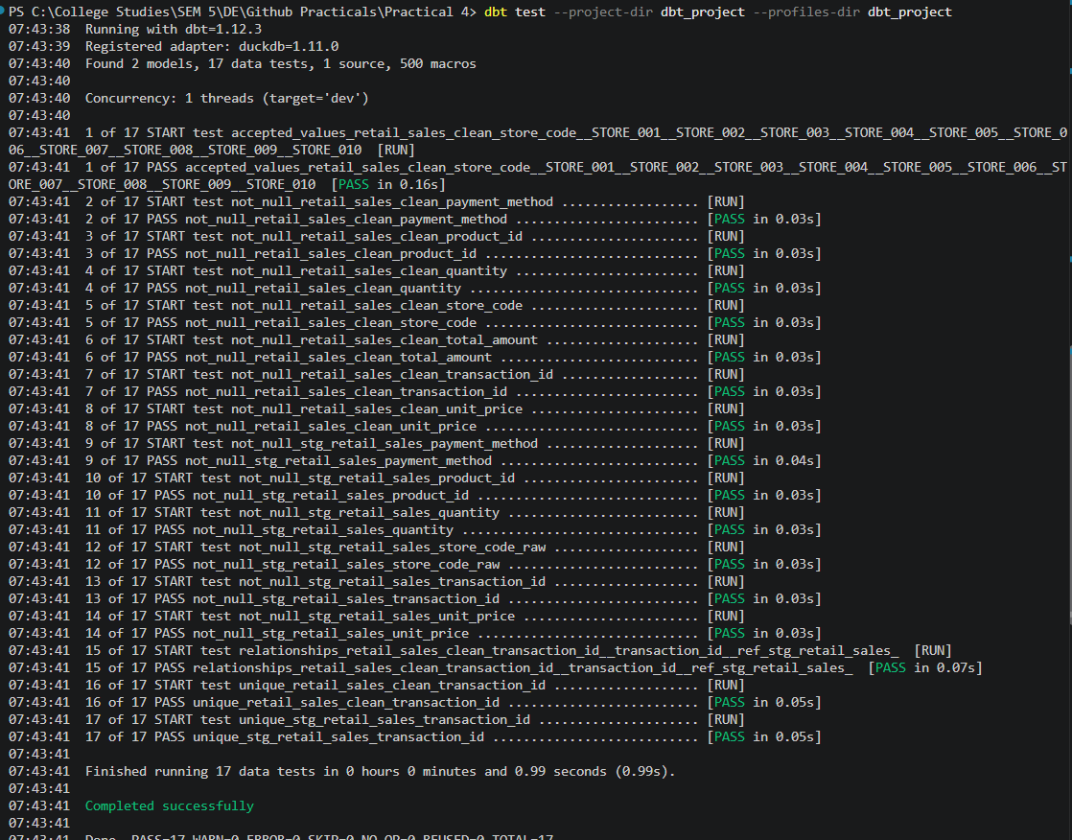

Output
- ETL and ELT pipelines were implemented.

- Both pipelines processed 100,000 records.
- Latency and throughput were measured.
- Comparison graphs were generated.
- ELT was refactored into dbt models.
- Automated schema tests were implemented.

Conclusion
ETL and ELT were successfully implemented and compared using the same retail dataset. In this local test, ETL completed faster, while ELT provided a clear raw-data staging approach. The dbt implementation also made the ELT transformations more organized and testable.

